**DIGITAL SYSTEMS II**

**LAB 3 REPORT**

1st student name: Akif Manzoor ID: 8298086.

2nd student name: John Brennan McDonald ID: 8195614

The Lab’s date Oct 21st, 2019:

**CHAPTER 4 (Multiplexer and Demultiplexer)**

2.1) Circuit Description

|  |  |  |  |  |
| --- | --- | --- | --- | --- |
| Selection | A | B | C | F |
| 00 | 0 | 0 | 0 | 0 |
| 00 | 0 | 0 | 1 | 1 |
| 00 | 0 | 1 | 0 | 1 |
| 00 | 0 | 1 | 1 | 1 |
| 00 | 1 | 0 | 0 | 1 |
| 00 | 1 | 0 | 1 | 1 |
| 00 | 1 | 1 | 0 | 1 |
| 00 | 1 | 1 | 1 | 1 |

2.2) Functional Simulation (ModelSim)

* ATTACH THE SCREENSHOT OF THE MODELSIM’S WAVE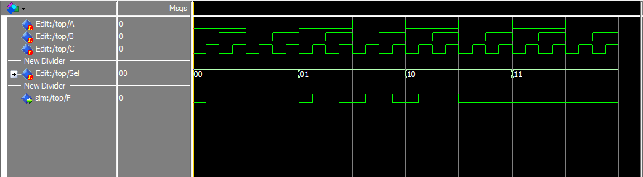
* ATTACH THE CODE OF THE MISSING PARTS (C4 and TOP)

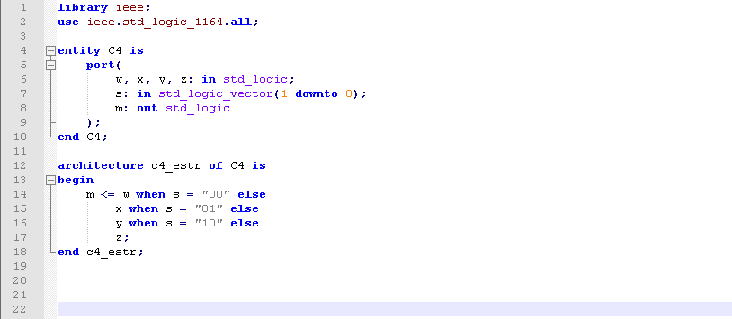

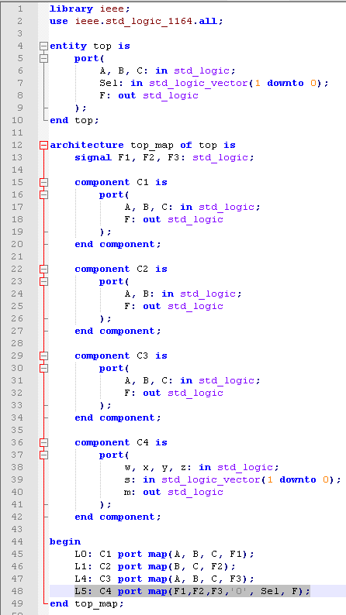

**CHAPTER 5 (Code Converters)**

3.1) Circuit Description

* DRAW THE CIRCUIT DIAGRAM OF THE ENTIRE CIRCUIT AND;

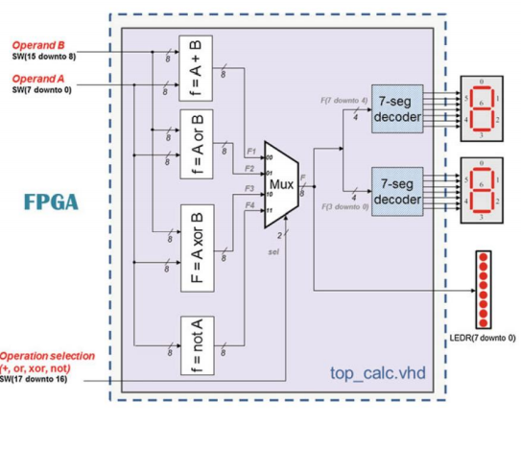

* COMPLETE THE TRUTH TABLE FOR THE FOLLOWING TEST CASES :
  + SW: 000000001000000001
  + SW: 010000001000000001
  + SW: 100000001000000001
  + SW: 110000001000000001

|  |  |  |  |
| --- | --- | --- | --- |
| SW(17 downto 16) | SW(15 downto8) | SW(7 downto 0) | Result |
| 00 | 00000010 | 00000001 | 00000011 |
| 01 | 00000010 | 00000001 | 00000011 |
| 10 | 00000010 | 00000001 | 00000011 |
| 11 | 00000010 | 00000001 | 11111101 |

3.2) Functional Simulation (ModelSim)

* ATTACH A SCREENSHOT OF THE MODELSIM’S WAVE

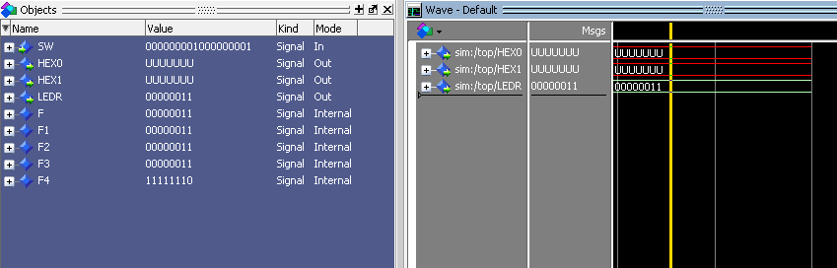

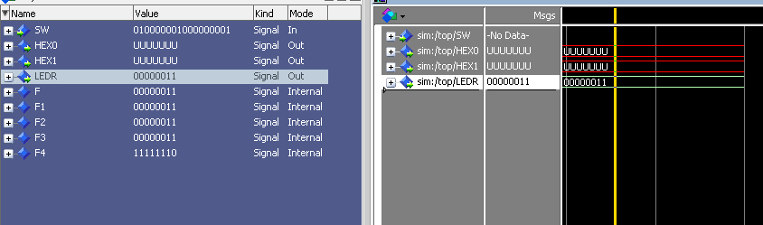

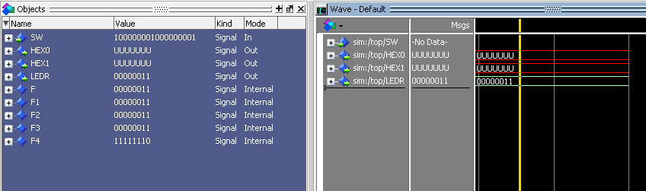

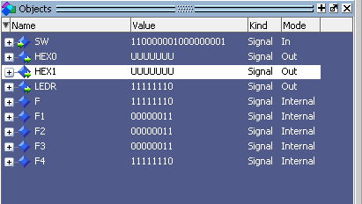

* ATTACH THE CODE OF THE MISSING PARTS (TOP)

